Synamedia MEG setup – **HSN**

HSN2 HD MP4 to SD MP2 - TSoip Out

**Task-** Configuring Synamedia MEG IRDs

**Condition-** Transcoding HSN2 HD from MP4 to SD MP2 - TSoip Out

**Standard-** How to configure a Synamedia MEG IRD for transcoding

**Action Items:**

* Transcoding HD MP4 to SD MP2
  + Begin by **Browsing to IP** of MEG IRD (Default ip - 192.168.2.20)
    - **Enter UN & PW** *(see figure 1) (UN: Admin; PW: Password)*

*figure 1 - Login*

* Click on **Add New Channel** *(see figure 2)*

figure 2 – Add Channel

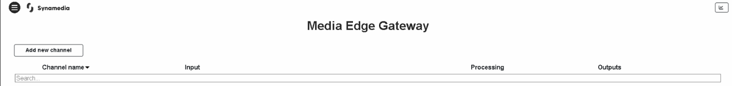

* + Choose which option you would like to do
    - Select **Linear** **Transcode** for ASI setup *(see figure 3)*

figure 3 - Transcode

]

* + Transcode – ASI
    - Enter a **Channel Name (HSN2 HD MP4 to SD MP2 - TSoip Out)**
    - Select **Use Existing Input**
    - **Input Selection - DVB-S2:DVBS2 1 (4.08GHz)**
    - Select which **Service ID** you would like to transcode by choosing the service in the **Dropdown Menu - (23) for HSN2 HD** *(see figure 4)*

figure 4 – Configure Transcode Options

* **Descrambling - Disabled**
* Click on **Video** tab next
  + Configure **Basic Video Settings**
  + Select the **Format** you would like to Transcode to
    - Select **SD**
  + Select **Codec** you would like to Transcode to
    - Select **MPEG2**
  + Select which **Resolution Mode** you would like to use
    - For SD services, select **Manual**
    - Verify the **Resolution** is set to **720x480p**
    - Verify **Frame Rate** is set to **29.97**
  + Leave defaults values for the remainder of settings *(see figure 5)*

*figure 5 – Choose Format and Codec*

* Click on **Audio** tab next
  + Click on **Add ES: 2301 (MPEG1-L2) (eng)**
    - Enable - Select **Transcode** for MPEG1-L2 audio *(see figure 6)*
    - Leave defaults values for the remainder of settings
  + Click on**Add ES: 2302 (Dolby Digital) (eng)** for Dolby Digital Audio
    - Select **Dolby Digital** in the **Encode** dropdown
    - Enable - Select **Passthrough** for Dolby Digital audio *(see figure 6)*
    - Leave defaults values for the remainder of settings

*Figure 6 – Configure Audio Settings*

* Click on **Service** tab next
  + Enter 2000 for delay (2 seconds) *(see figure 7)*

*figure 7 – Configure Processing Delay*

* Click on **Output** next
  + Select **Type** 
    - Select **Xgress**
      * Select which **Xgress port** you would like to use (Port-1)
      * Host 225.1.1.5
      * UDP 49152
      * Leave remaining fields as default values
  + Tick **Service ID** box
  + Enter **Service ID – 23** *(see figure 8)*

*Figure 8 – Configure Output*

* Click on **Create** in upper right corner *(see figure 9)*

*Figure 9 – Create and Finish*

* *You should see a popup box that says “Channel activated successfully”*
* Setup complete –There should now be 1 channel with a green checkmark *(see* ***figure 10)***

*Figure 10 – Channel Created*

*Advanced View configurations are beyond the scope of this document.